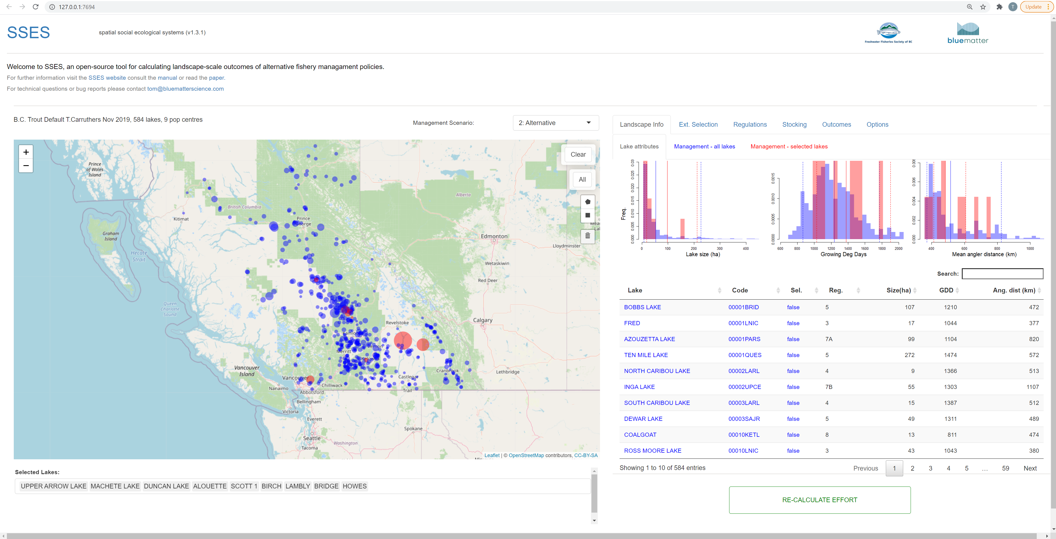

**L**

**K**

**J**

**I**

**H**

**G**

**F**

**E**

**D**

**C**

**A**

**B**

A: Name of landscape object

B: Map of selected (red) / not-selected lakes (are of circles is related to lake surface area)

C: Selected lakes. User can add lakes by typing text in here, and also delete lakes by selecting them and keyboard ‘del’

D: Management scenario currently selected

E: Visual selection tools (Clear – removes all selected lakes, All – selects all lakes, Shape buttons – create polygons for selection, Garbage button - removes all selection shapes)

F: Landscape Info Tab. Presents a summary of the characteristics of all lakes (blue) and selected lakes (red)

G: Extended Selection Tab. Other tools for adding / subtracting selected lakes.

H: Regulations Tab. For editing fishery regulations on selected lakes for this management scenario

I: Stocking Tab. For changing the stocking rates of selected lakes for this management scenario.

J: Outcomes Tab. To evaluation the social and ecological impact of alternative management scenarios.

K: Options Tab. For loading and saving landscape objects, renaming scenarios and altering calculation parameters.

L: Re-calculation button. When either regulations or stocking are changed, the impact on outcomes must be recalculated.

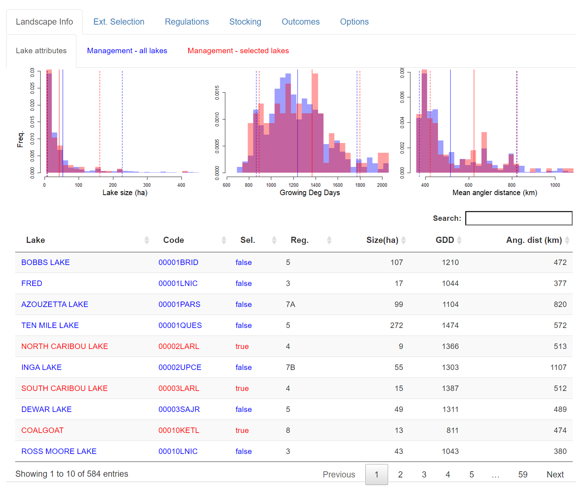

**E**

**C**

**A**

**D**

**B**

A: Users can select an overview of lake attributes

B: Three attributes are plotted: the Frequency of the lake sizes, the growing degree days, mean angler distance (whole landscape of anglers) from selected lakes

C: Individual lake attributes are tabulated and can be sorted by any of the fields including Lake Name (Lake), Lake Code (Code), whether it has been selected by the user (Sel.), the Region (Reg.), the surface area of the lake in hectares (Size), number of growing degree days (GDD) and the mean angler distance (Ang. Dist.).

D: Alternatively, users can use the search box to narrow results to specific entries.

E: All lakes are displayed with entries running over multiple pages (here from 1 to 59).

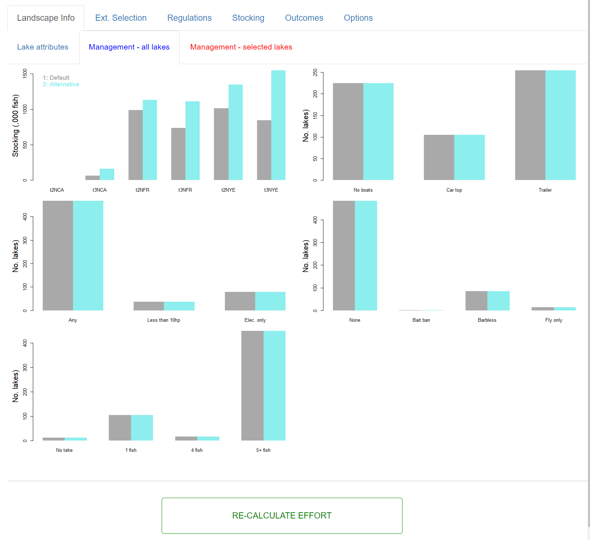

**F**

**E**

**D**

**C**

**A**

**B**

A: The frequency of stocking types among two management scenarios (in this case Default and Alternative). In this example the only difference between the proposed management scenarios is stocking.

B: Boat restrictions

C: Engine restrictions

D: Gear restrictions

E: Bay limits

F: The Landscape Info shows the differing specification of two management scenarios – however to see outcomes you need to make sure you have re-calculated fishing effort.

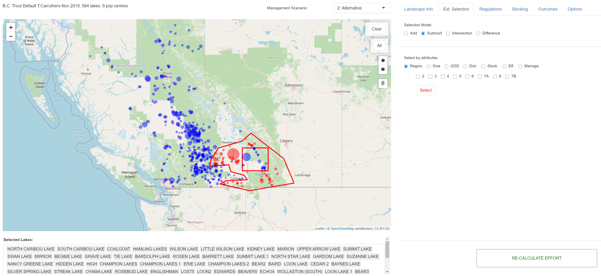

**F**

**B**

**E**

**D**

**C**

**A**

A: Users can select lakes by clicking on the corresponding blue circle on the map.

B: Alternatively, users can select individual lakes by name in the text box below the map.

C: Using the polygon buttons users can specify geographic areas to encompass a set of lakes. The Clear button clears all selected lakes. The All button selects all lakes. The garbage bin removes all drawn polygons.

D: When adding shapes or clicking on individual lakes, users can add these to the current selection, subtract them, only keep those that are currently selected and were selected previously (intersection) or select the difference among the previously selected and currently selected (difference). These modes work with all types of lake selection.

E: Additionally, users can select lakes according to their management region, lake surface area (size), growing degree days (GDD), road distance from closest population center (Dist.), stocking type (Stock.), current fishing effort (Eff.), and management regulations (Manage.)

F: To select the lakes according to your specifications, you need to press the ‘select’ button.

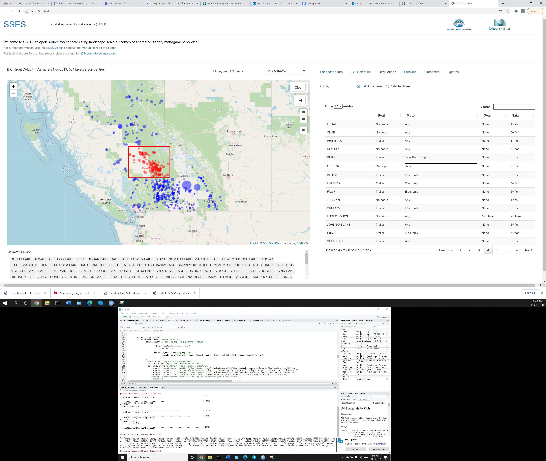

**B**

**A**

**B**

A: Users can select to edit management regulations by individual lakes or edit all of the selected lakes

B: When edit by Individual lakes is selected, the user can find a specific lake and then can edit the regulations manually by double left-mouse clicking on the cell, in this case here changing the Motor restrictions for the lake ‘Green2’.

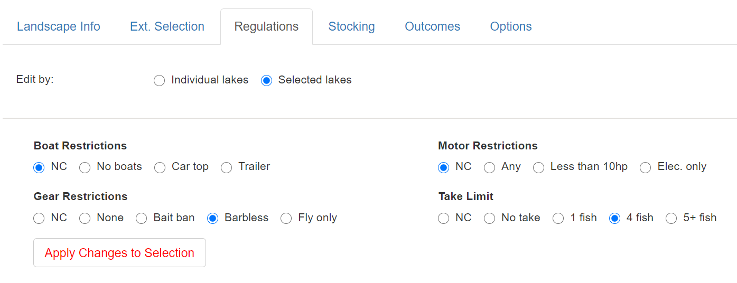

**C**

**B**

**A**

A: Regulations can be changed for all of the selected lakes at once.

B: These can include Boat Restrictions, Motor Restrictions, Gear Restrictions and Take Limits. In this case the user has opted to change gear restrictions to barbless hooks and limit take to 4 fish. No changes (NC) have been specified for boat and motor restrictions.

C: To apply these changes to the selected lakes the user must press the Apply Changes to Selection button.

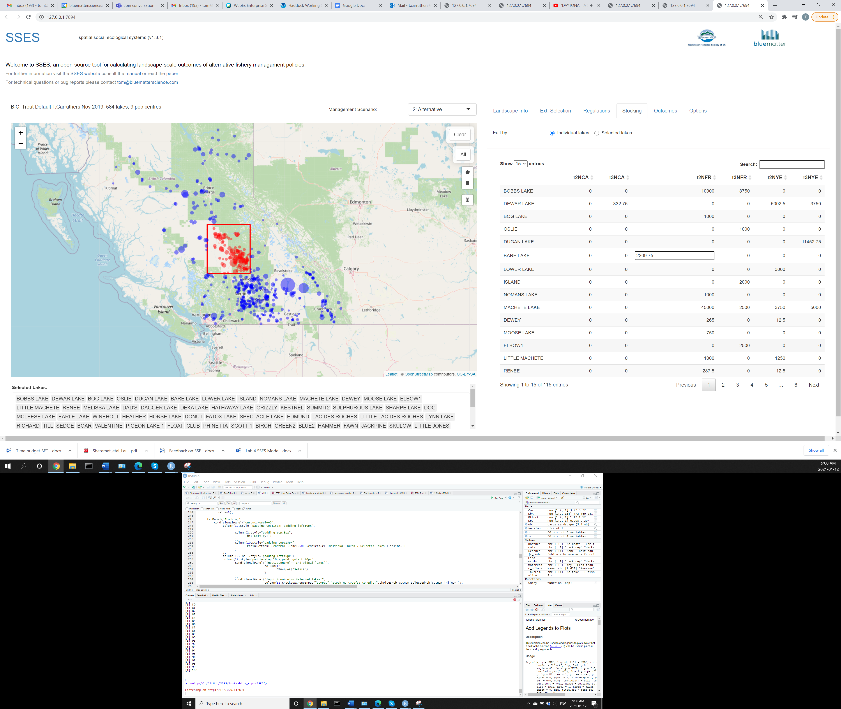

**B**

**A**

A: Similarly to Regulations, the user can edit stocking rates by individual lake.

B: Double left-mouse clicking on a cell in the table allows the users to edit a specific stocking amount. In this case the annual stock rate of diploid fry in Bare Lake.

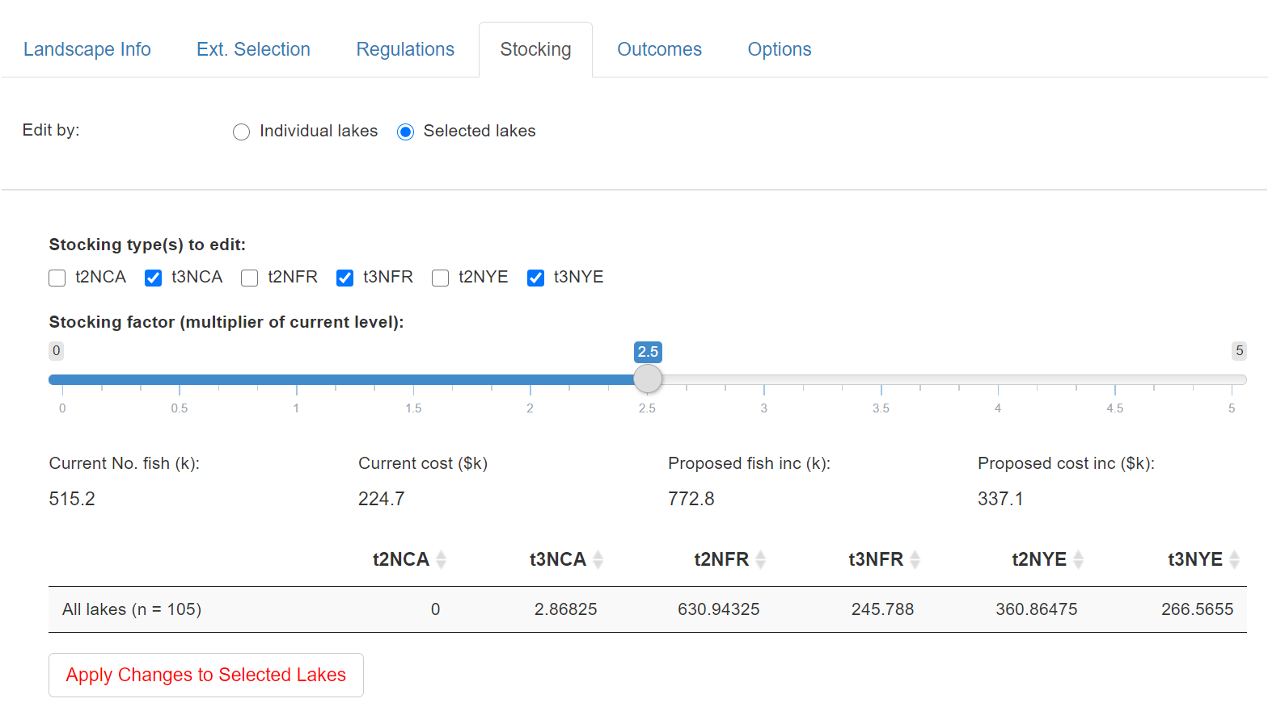

**F**

**E**

**D**

**C**

**B**

**A**

A: Stocking can be changed for all selected lakes

B: The user can specify which stocking types to change. Here the user is opting to modify stocking for triploid catchables (t3NCA), triploid fry (t3NFR) and triploid yearlings (t3NYE).

C: The stocking factor is the fraction of the current stocking level to apply. In this case the user has chosen a factor of 2.5 (a 150% increase in stocking).

D: The current stocking numbers and cost are provided in addition to the proposed increase in stocked numbers and increased costs.

E: The new proposed stocking levels are show in a table.

F: In order to apply this proposed stocking change the user must press the ‘Apply Changes to Selected Lakes’ button.

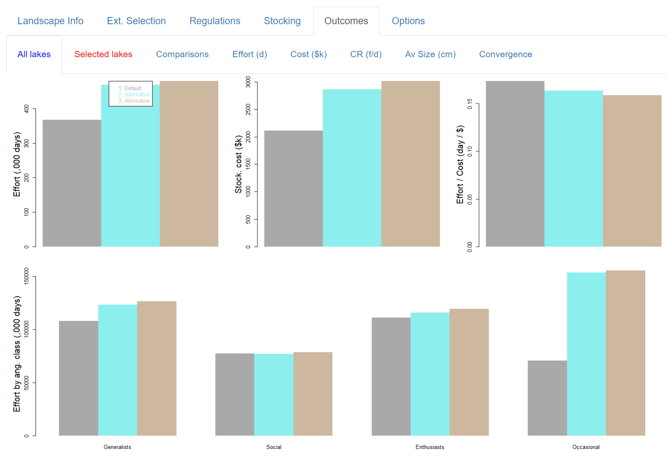

**E**

**C**

**B**

**D**

**A**

A: Outcomes can be presented over all lakes, selected lakes. ‘Comparisons’ provides differences in outcomes with respect to a specified management scenario. Tables are available that show lake-specific outcomes for Effort (days), Stocking costs, catch rates (fish per 4-hour ‘day’) and average size of fish caught. ‘Convergence’ provides a diagnostic of whether the effort calculation was stable (conclusions are not changing as the numerical approximation to the ideal free distribution progresses).

B: Total angling effort.

C: Stocking costs.

D: Effort per stocking (a measure of efficiency).

E: Effort by angler class.

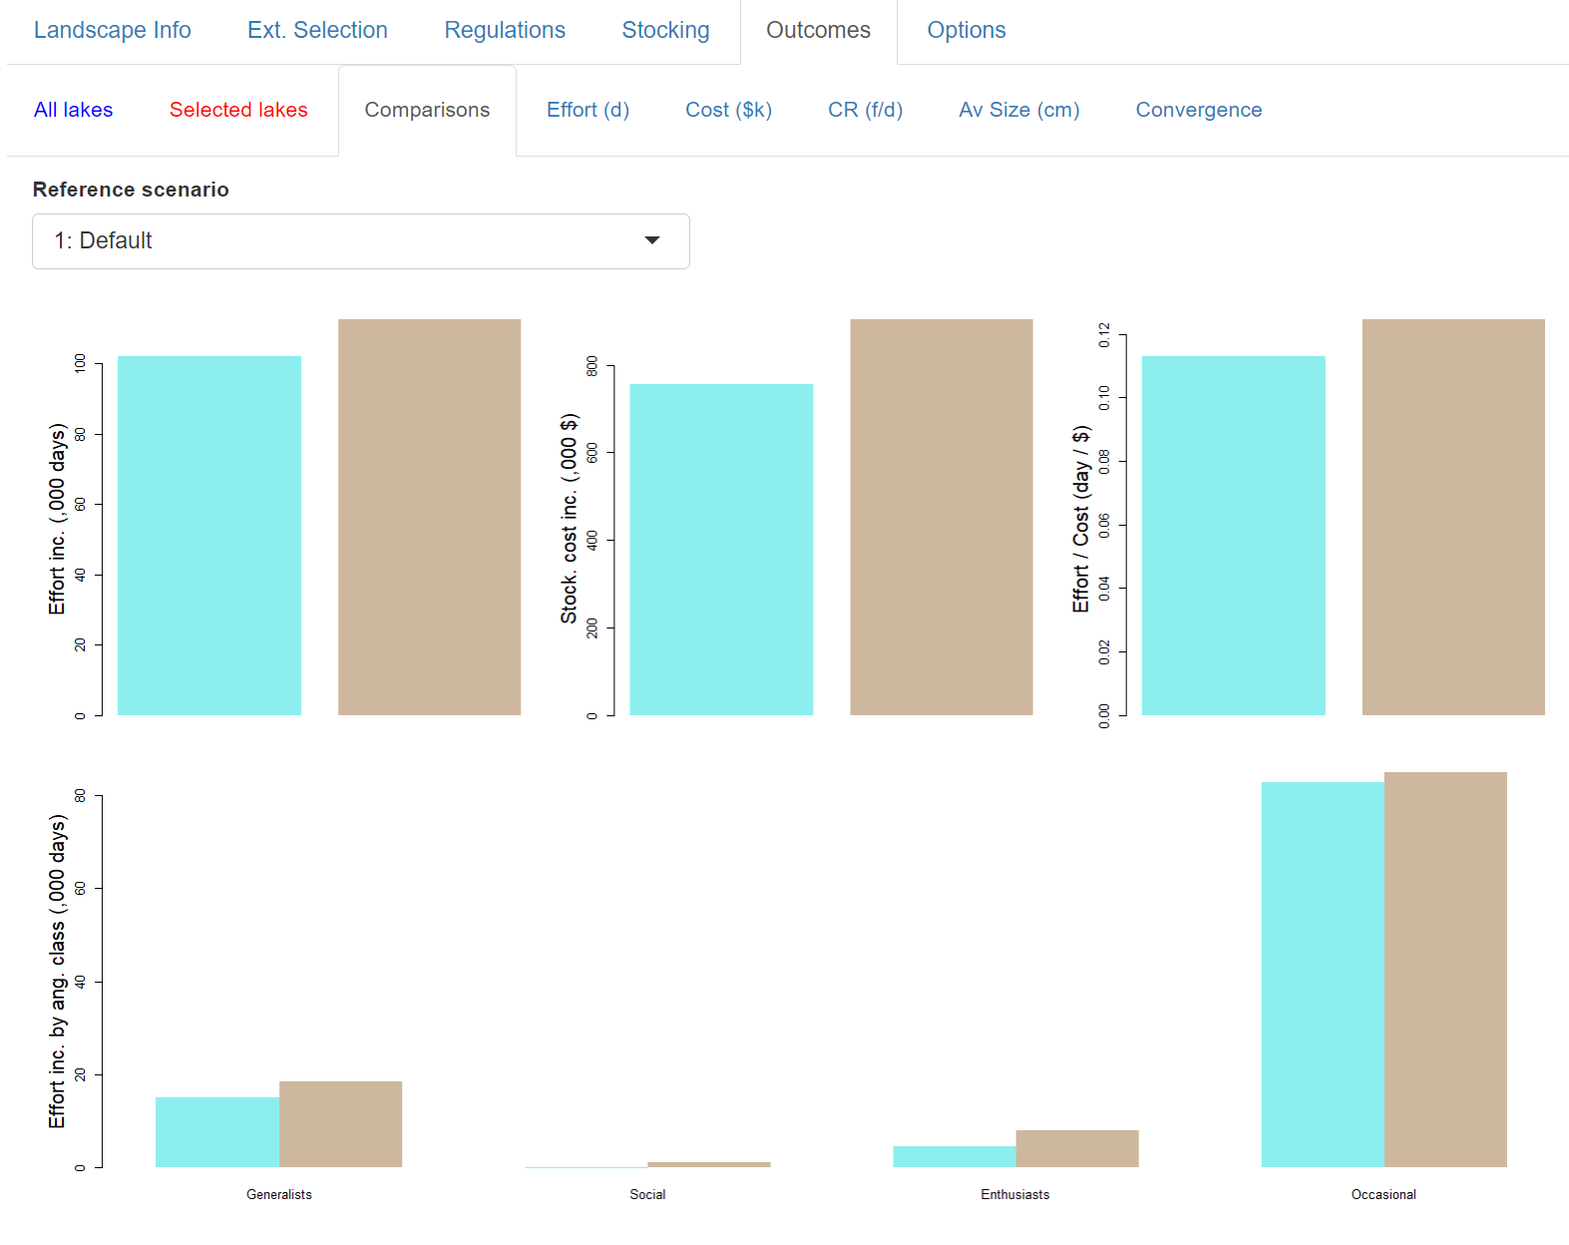

**A**

**B**

A: The user can select a reference management scenario for presenting differences in outcomes for all lakes.

B: The same metrics are presented as differences from the reference management scenario (e.g. positive values are increases compared with the reference management scenario)

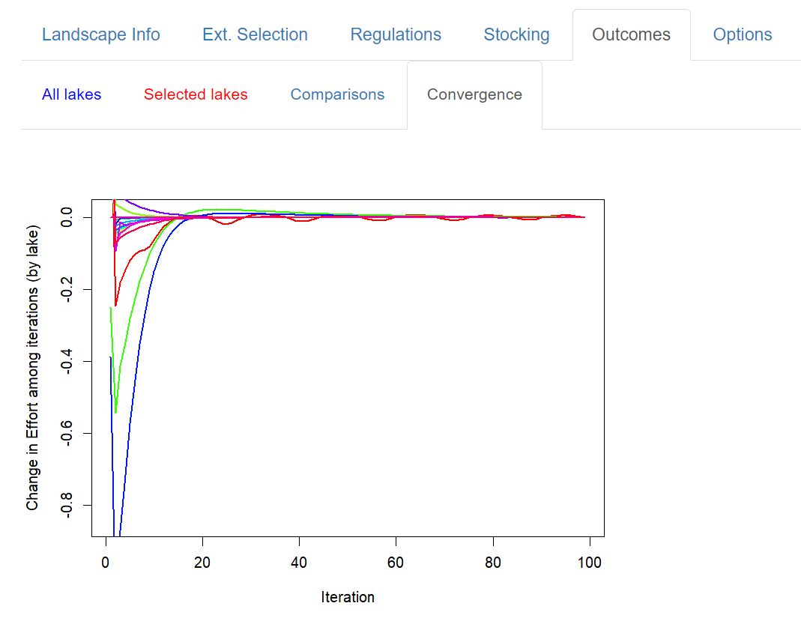

**D**

**C**

**B**

**A**

A: The convergence graph shows how angling effort by lake stabilizes as the numerical algorithm (approximation to the ideal free distribution of effort) progresses (higher iterations on the x axis). Each line represents the effort of a modelled lake.

B: Effort for some lakes converges quickly (e.g. the red line) and conclusions about effort are stable (+/- a small amount of effort) after just 15 iterations.

C: For other lakes the effort converges less quickly (e.g. the green line which only gets very close to zero after around 40 iterations).

D: The user specifies a maximum number of iterations (in this case 100). The objective of this plot is to provide the user with confidence that the outcomes plotted (which correspond with the maximum iteration) are stable and not spurious. This plot can also be used to speed up run time by specifying fewer maximum iterations. If, for example, +/- 0.05 effort by lake could be considered by the user to be ‘stable’ then a maxim iteration number of around 40 would be sufficient going by this plot. Note that convergence is very dependent on the management scenario and convergence should always be checked. The default setting of 100 iterations errs on the side of caution, more certain stability and longer running times.

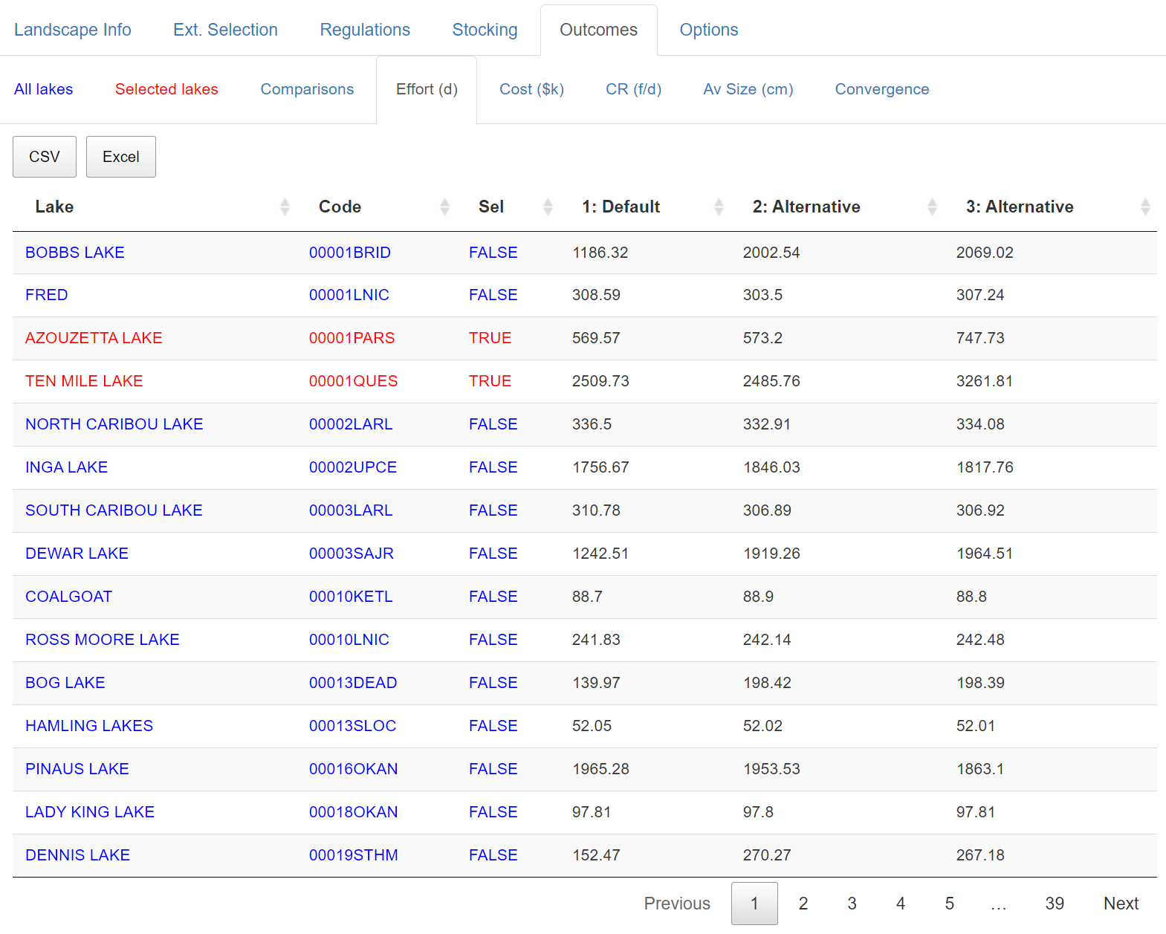

**E**

**D**

**C**

**B**

**A**

A: Overall angling effort by lake (days).

B: Stocking cost by lake ($k).

C: Expected catch rate (fish per 4-hour ‘day’).

D: Average size of fish caught (cm).

E: Result can downloaded in raw csv format or as an excel spreadsheet.

**C**

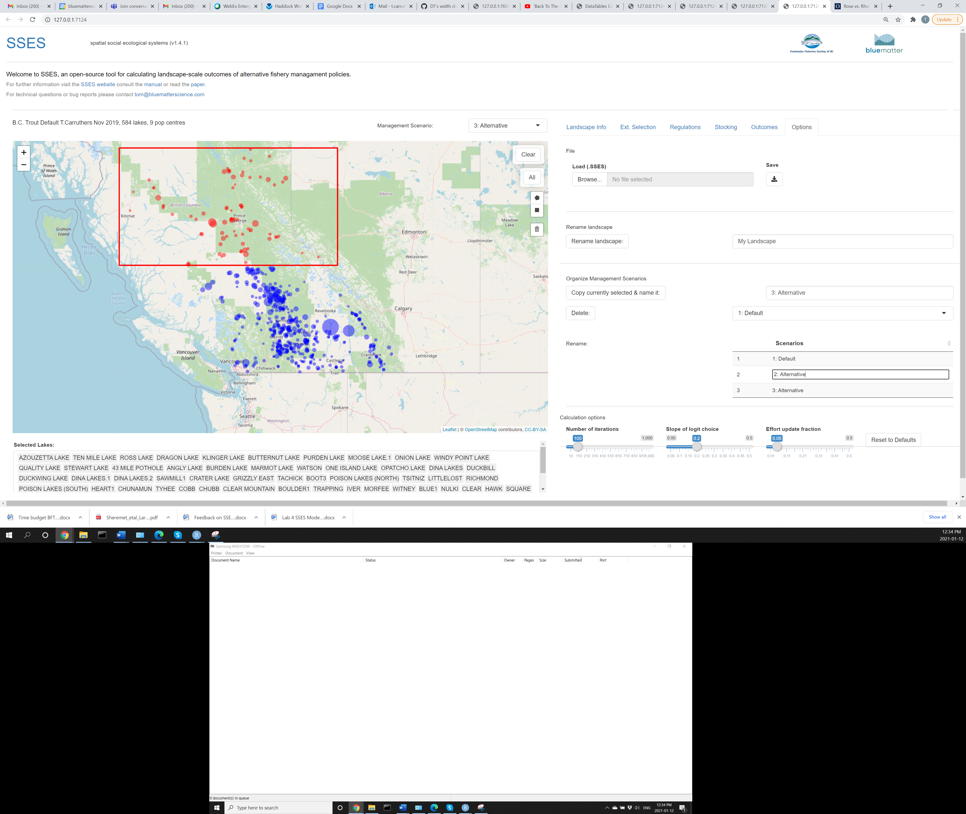

**H**

**G**

**F**

**E**

**D**

**C**

**B**

**A**

A: Load a saved .SSES landscape object.

B: Save currently specified .SSES landscape object.

C: Copy the currently selected management scenario (in this case Alternative 3) to make a new management scenario.

D: Delete a management scenario

E: Rename an existing management scenario by double left-mouse clicking on a field in the table

F: Alter the maximum number of iterations used in the numerical approximation to the ideal free distribution of effort (outcomes are presented for the final iteration)

G: Alter the slope of the logit choice model – this affects the strength with which gravity differences affect lake selection.

H: the fractional update in effort distribution in each iteration of the numerical approximation. Lower fractions provide slower but more stable convergence on the ideal free distribution of effort.